**Agile Development**

Agile is an iterative approach to project management and software development that helps teams deliver value to their customers faster

It is a software development life cycle(SDLC).

While handling the large projects,earlier we use waterfall model methodology.

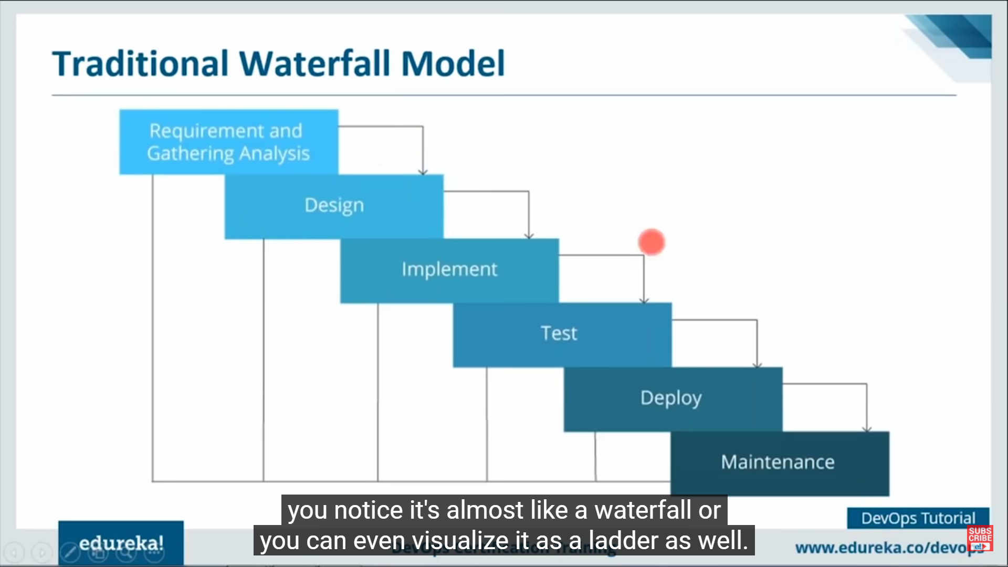

Because of the limitations of waterfall model,We will be using Agile methodology.There’s no revert back in waterfall if any bug identified.

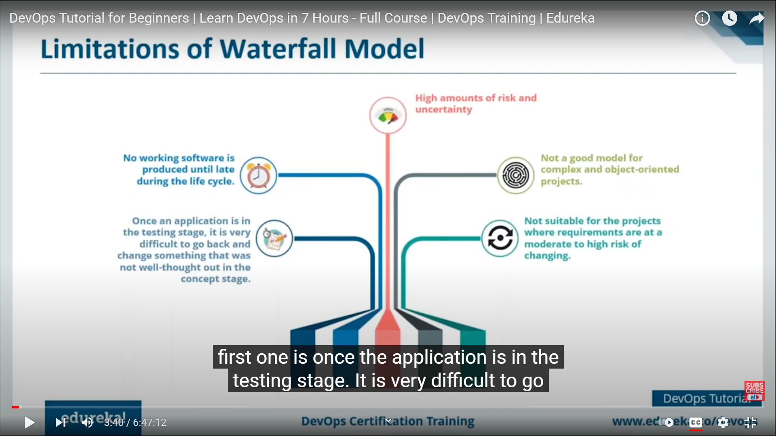

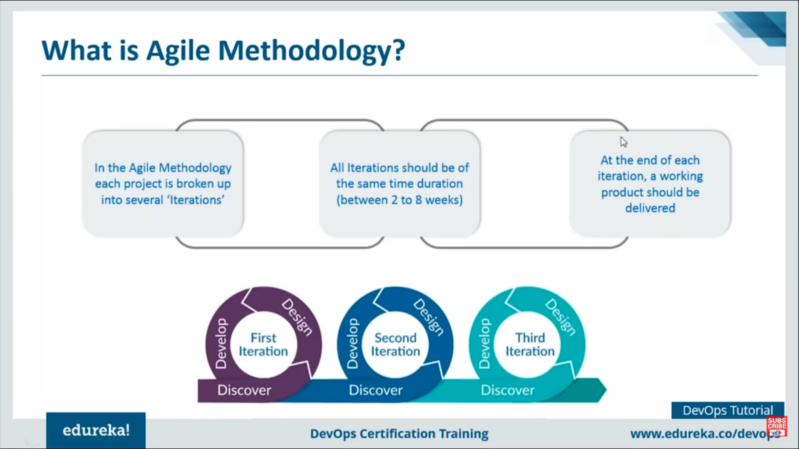

As waterfall model have continuous stages of development of code.

I.e. planning,designing,building,testing and the deployment.No revertback to initial stages whereas Agile development works in iteration of tested code to design and the develop again and again then deploy.

Devops is a practice of operations and development engineers participating together in the entire software life cycle from design through the development process to the production support

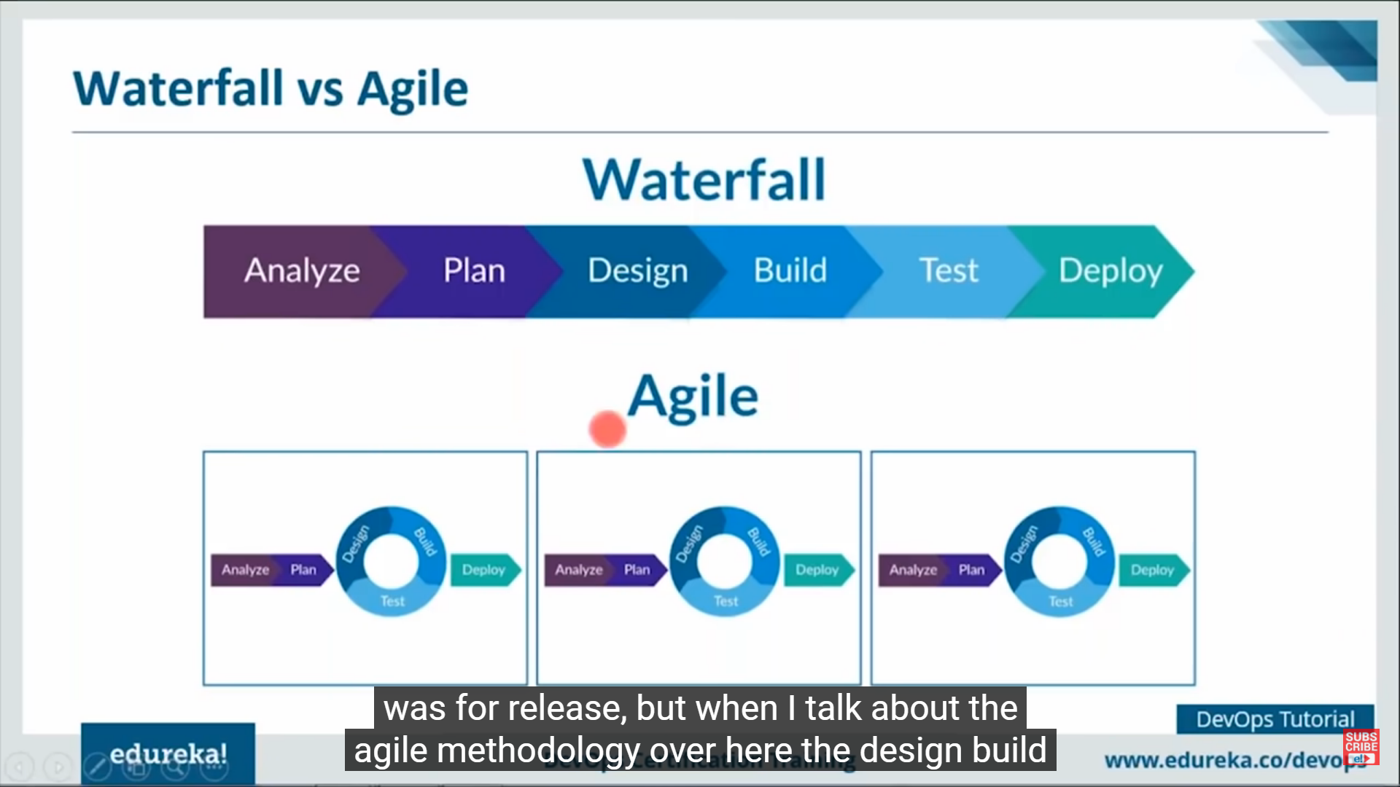

1. **Planning**
2. Working together

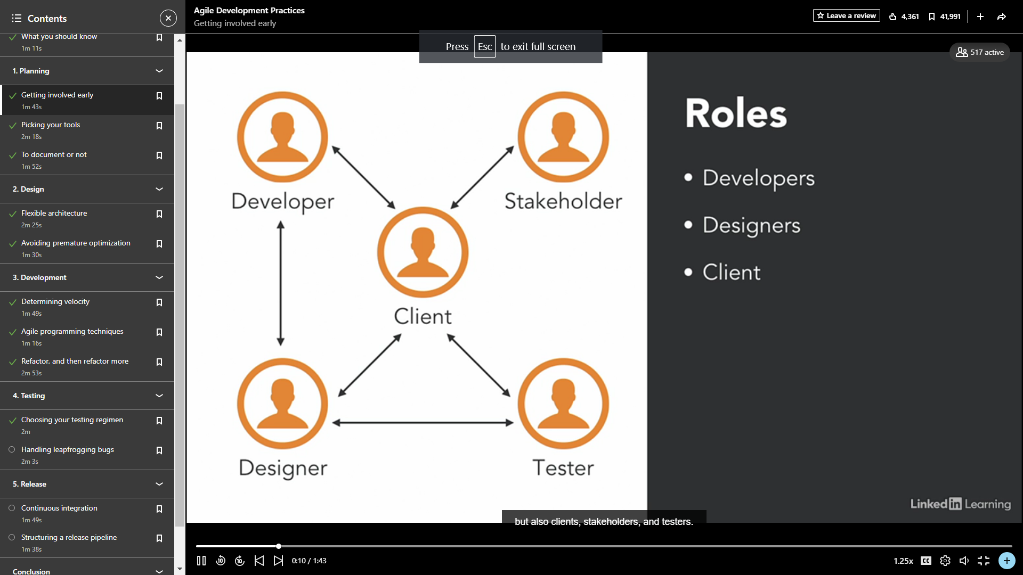

Pick tools for planning.

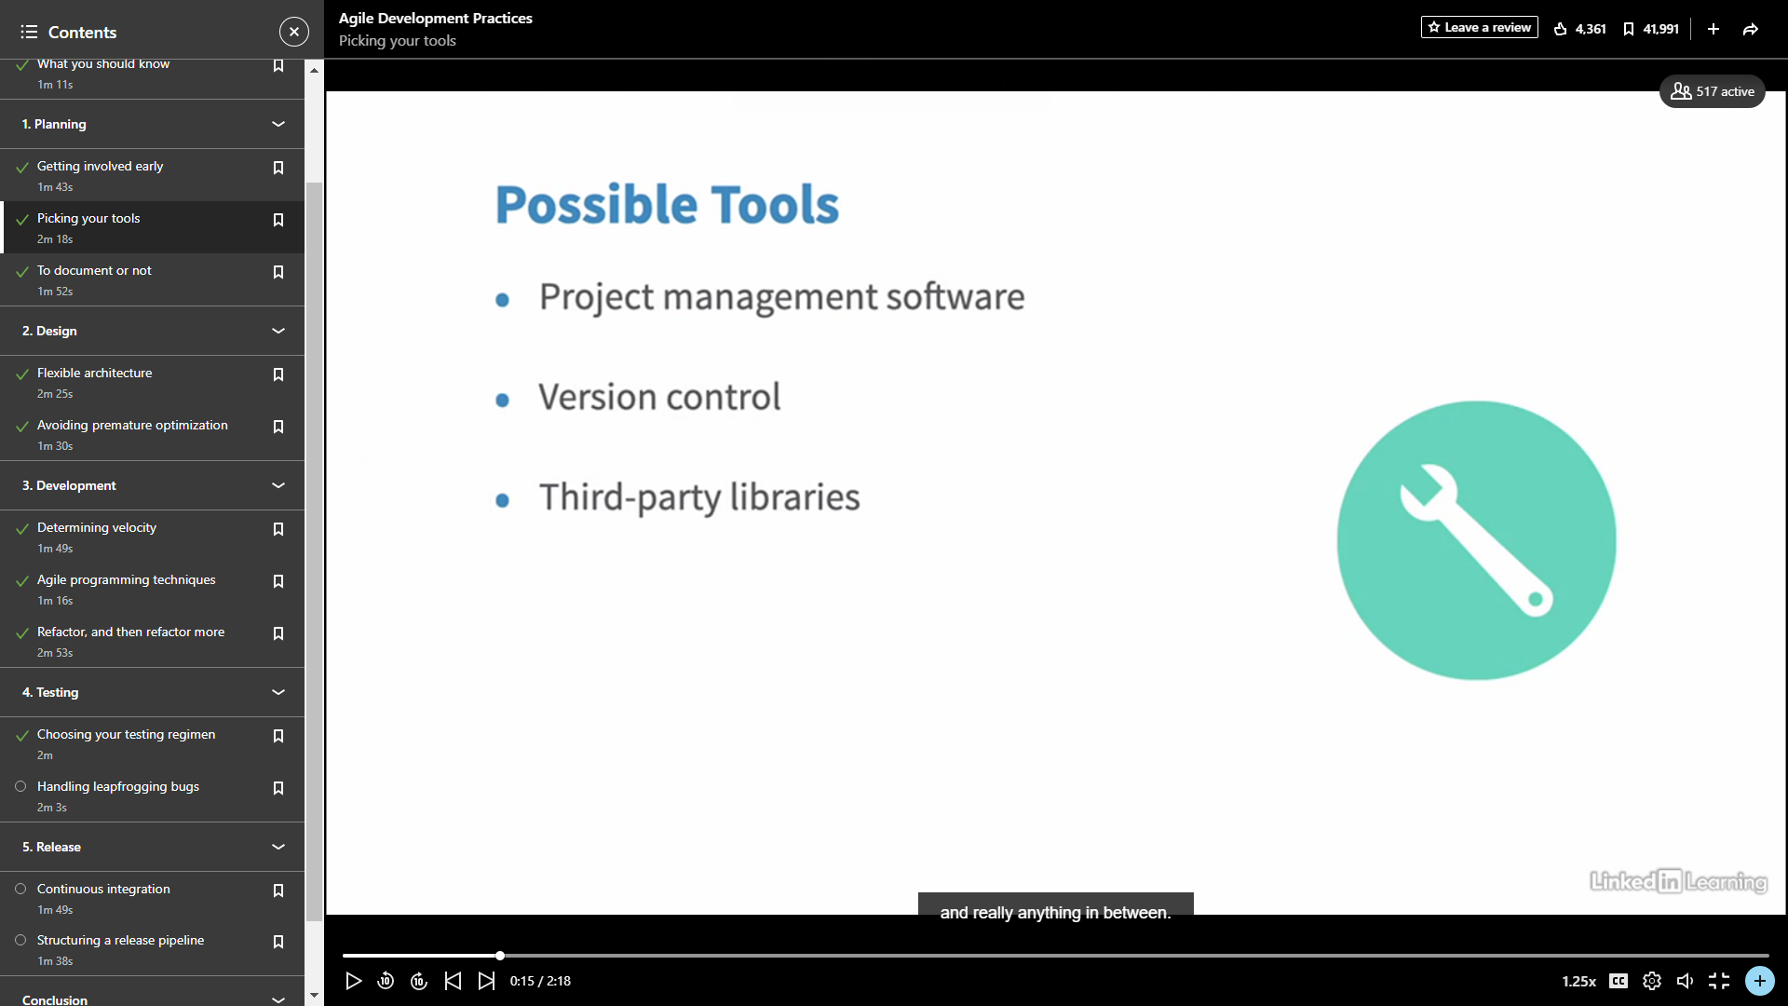

No documentation until its not required.

1. **Design**

Make it flexible and adaption coz of iterative in nature.

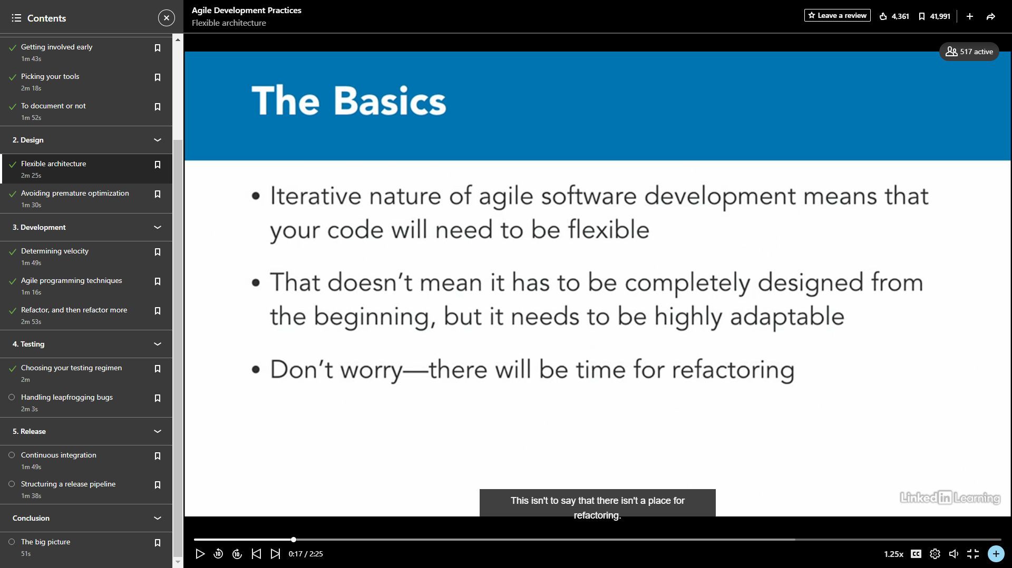

1. Good design Pattern
2. Deadlines and changing requirements.
3. Bugs client feedback.Makes it adaptable.
4. Avoiding premature optimization→avoid spending time more on the things.
5. **Development**

The first thing is sprint velocity how much time we are spending.

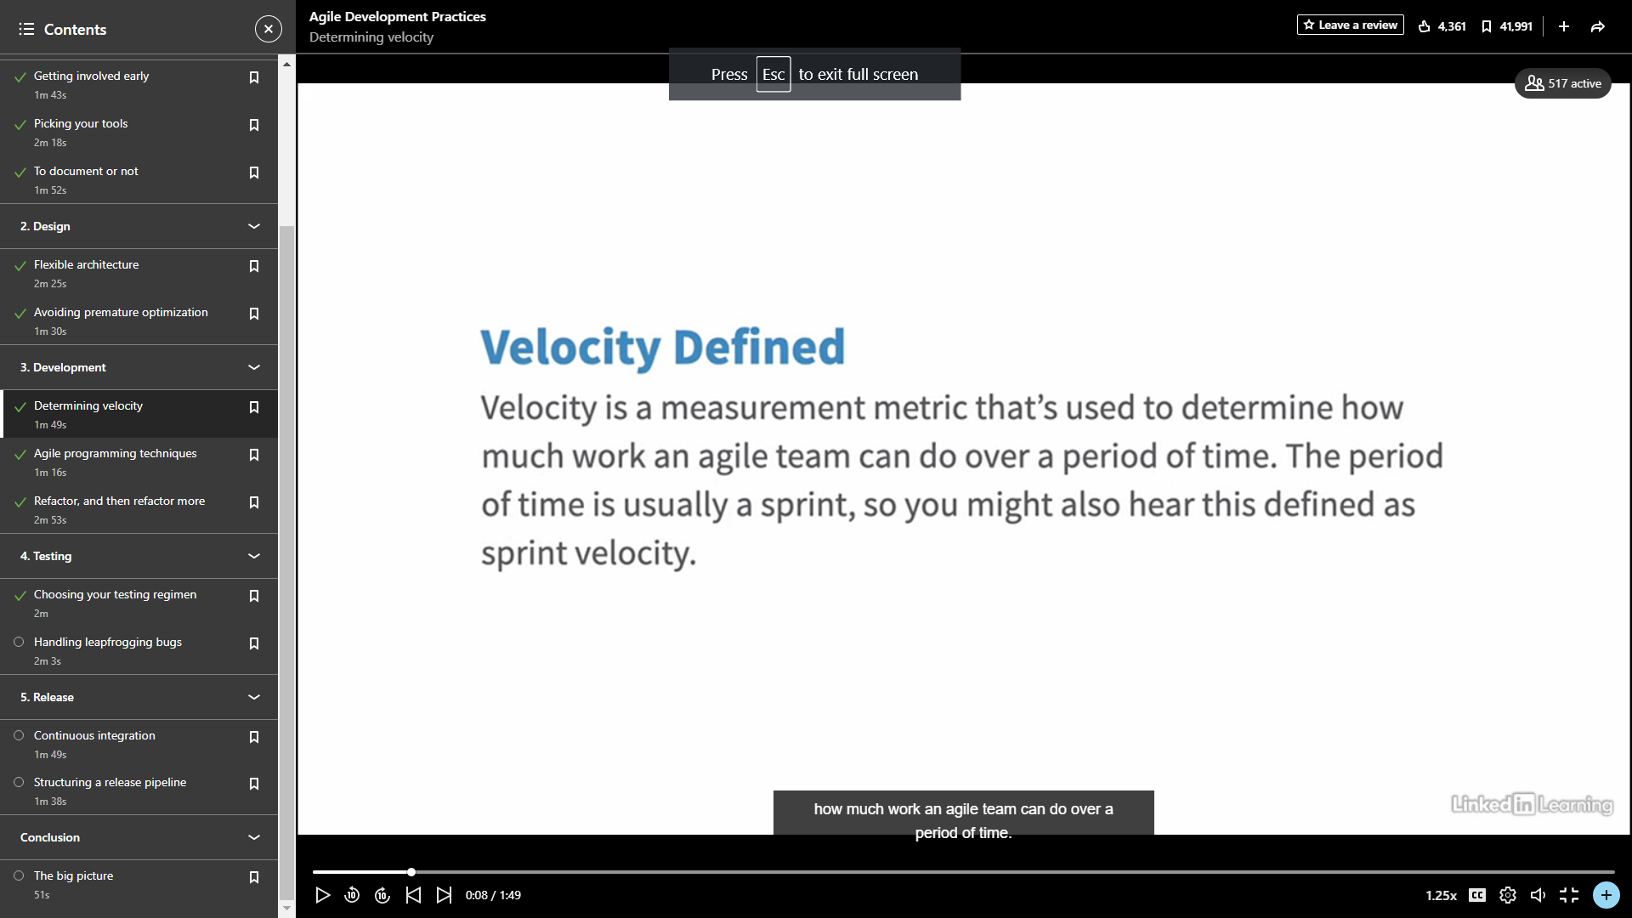

Refactor more.

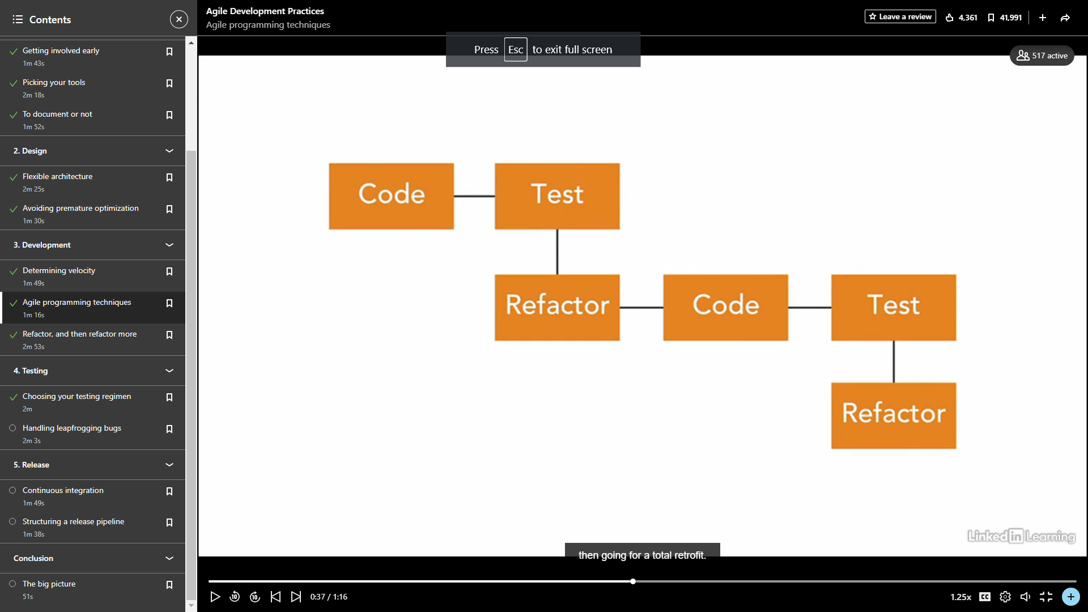

Pair programming and test driven development are most imp for agile dev.

1. Pair programming

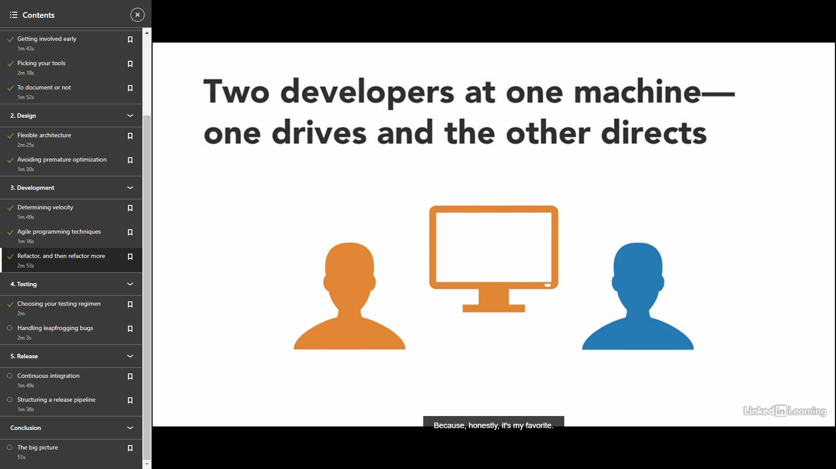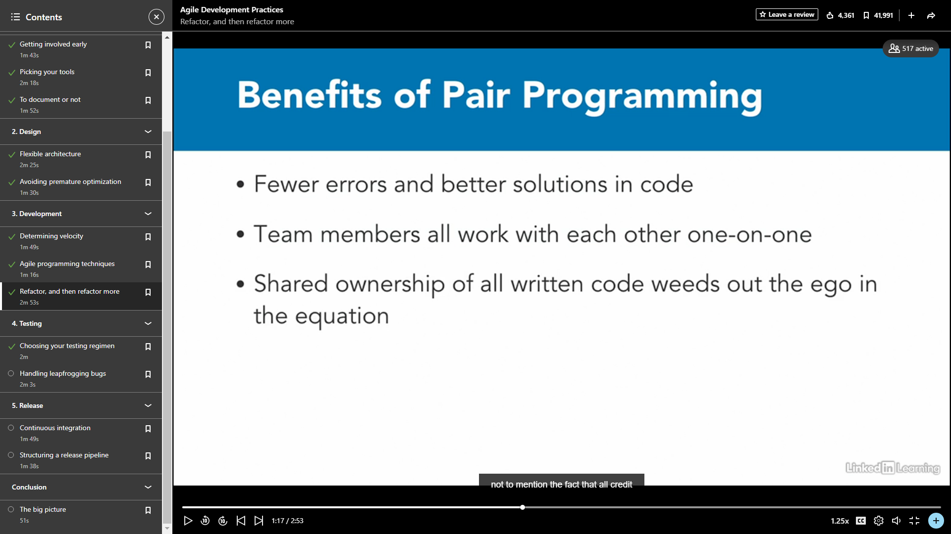

1. Test driven development

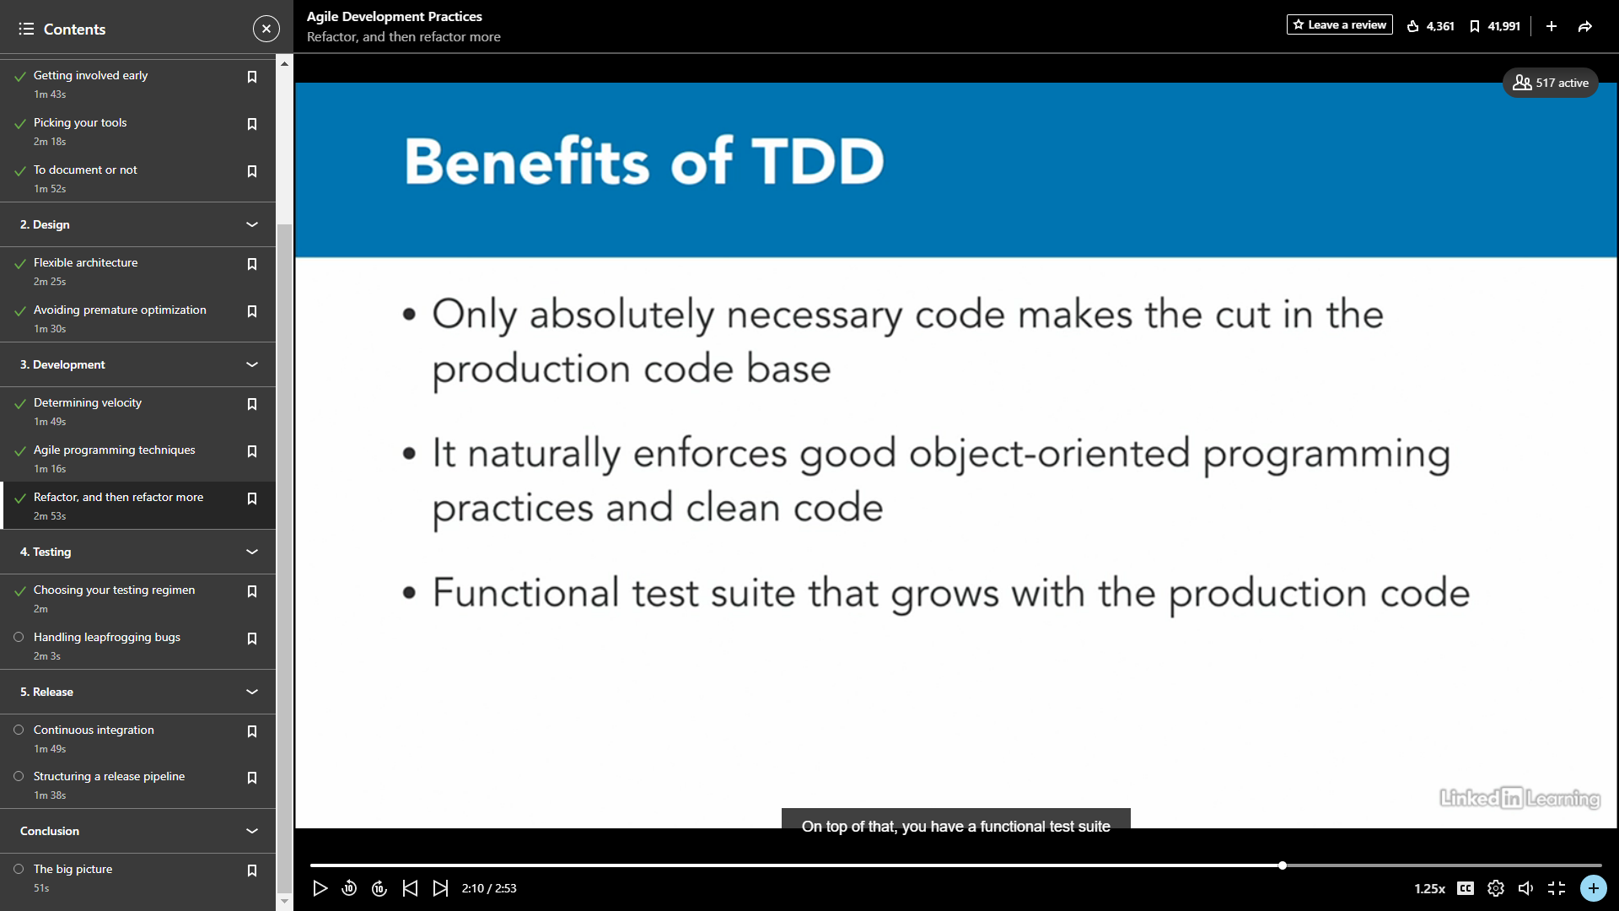

1. **Testing**

Choosing your testing regimen

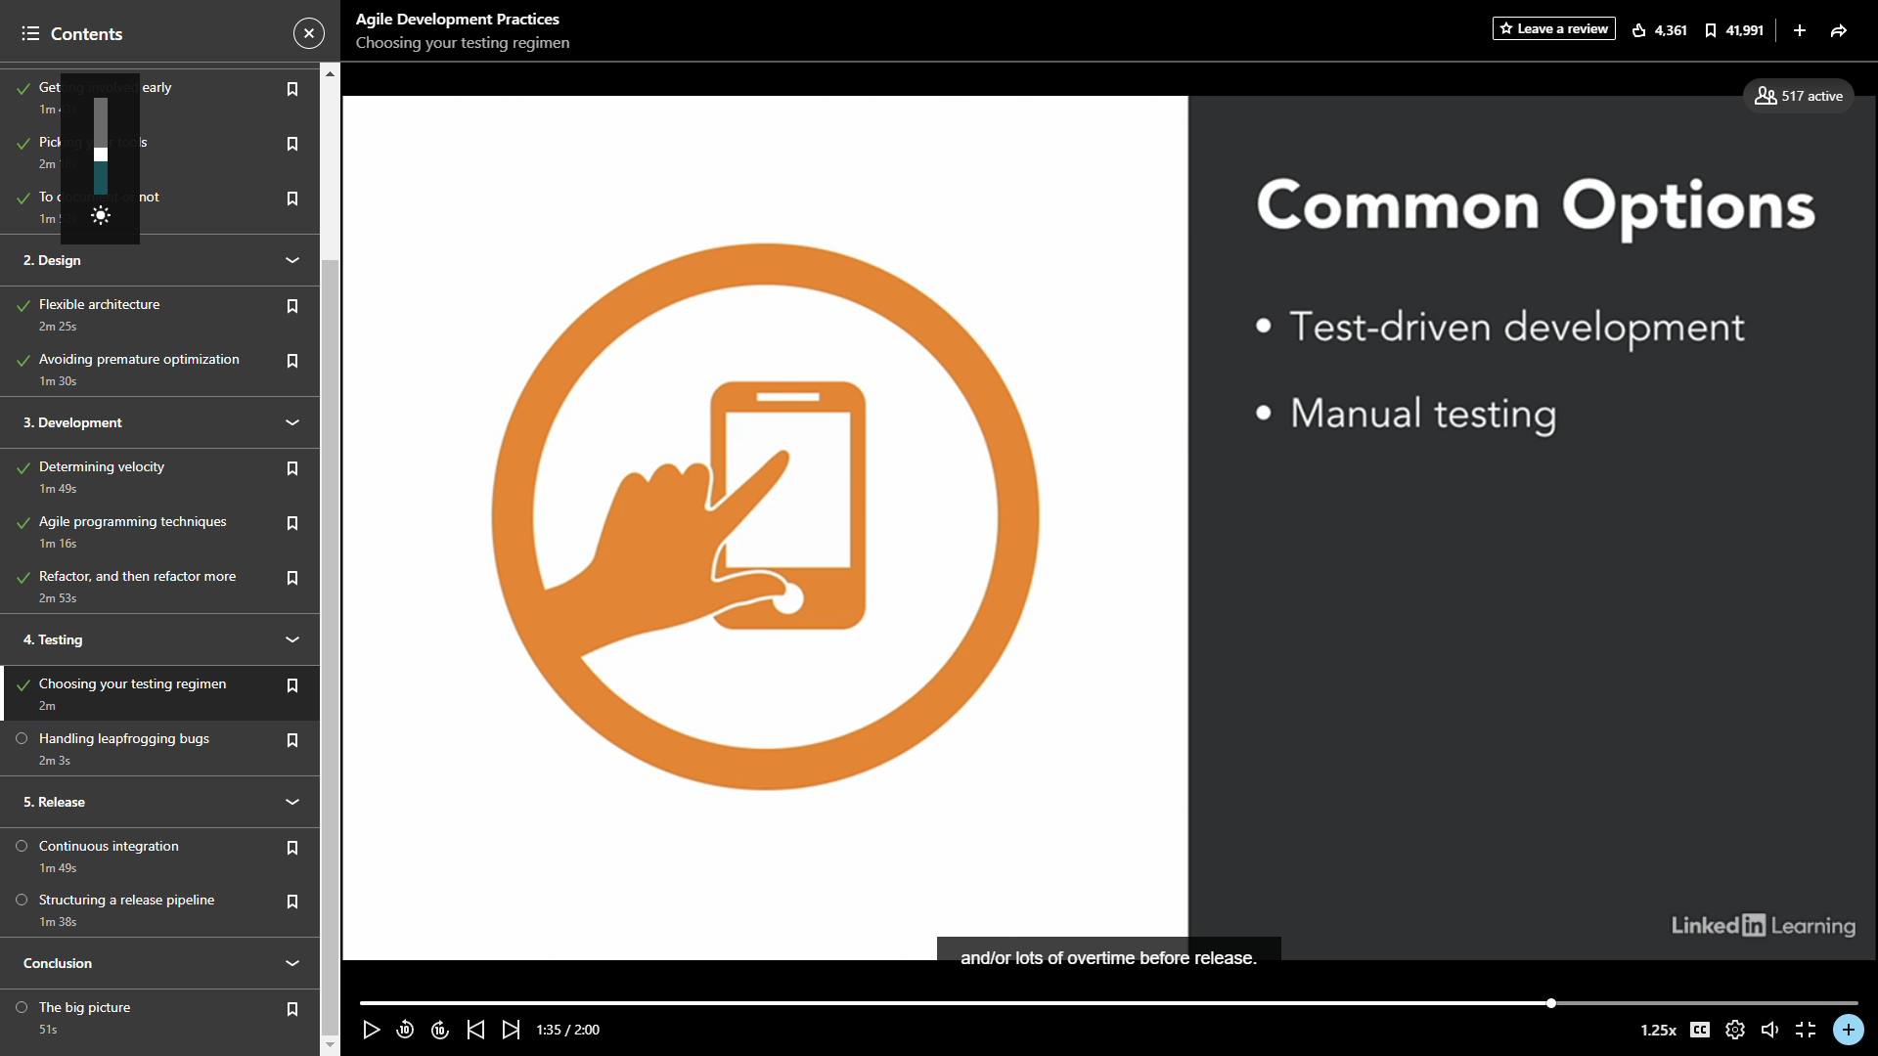

Handling leapfrogging bugs

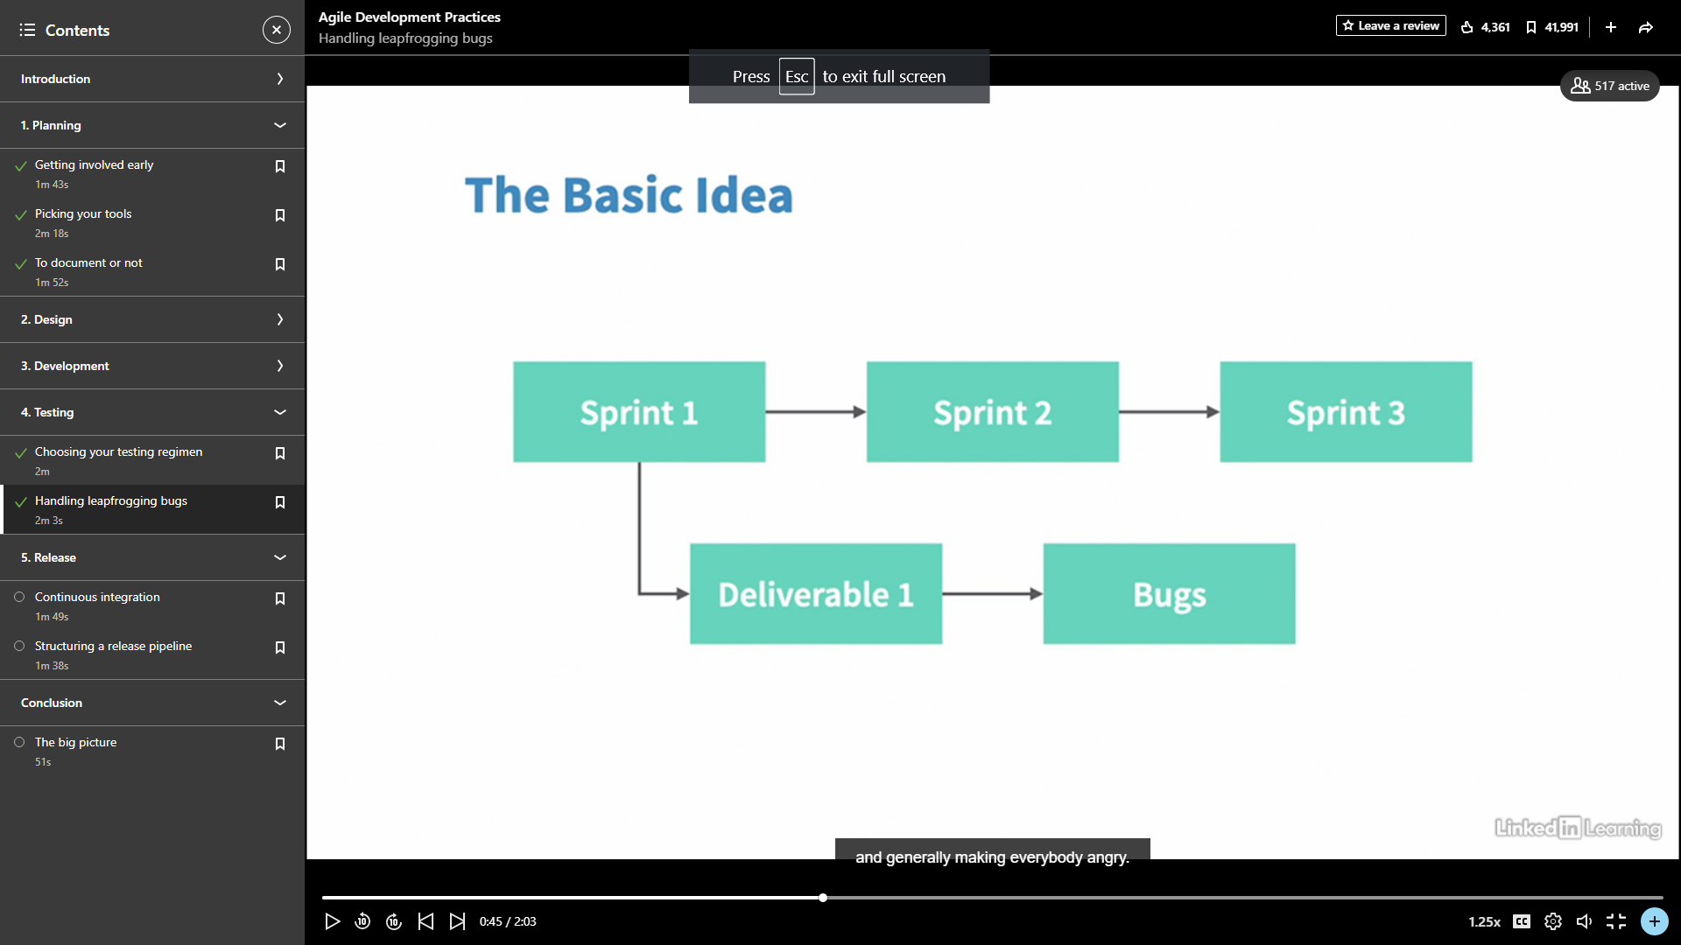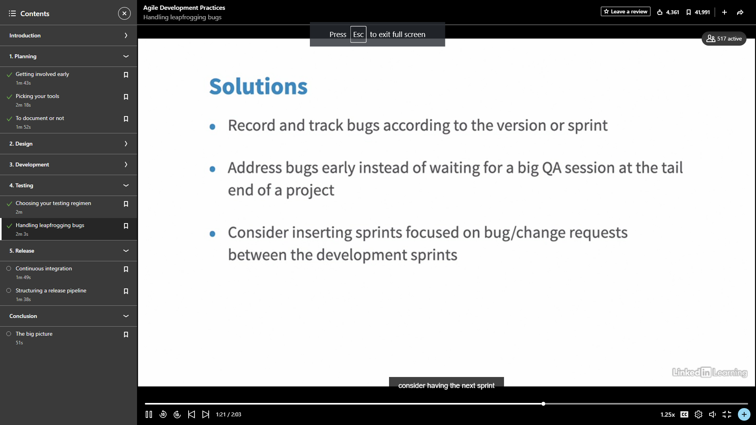

1. **Release**

Continuous Integration

Continuous integration is a DevOps software development practice where developers regularly merge their code changes into a central repository, after which automated builds and tests are run.

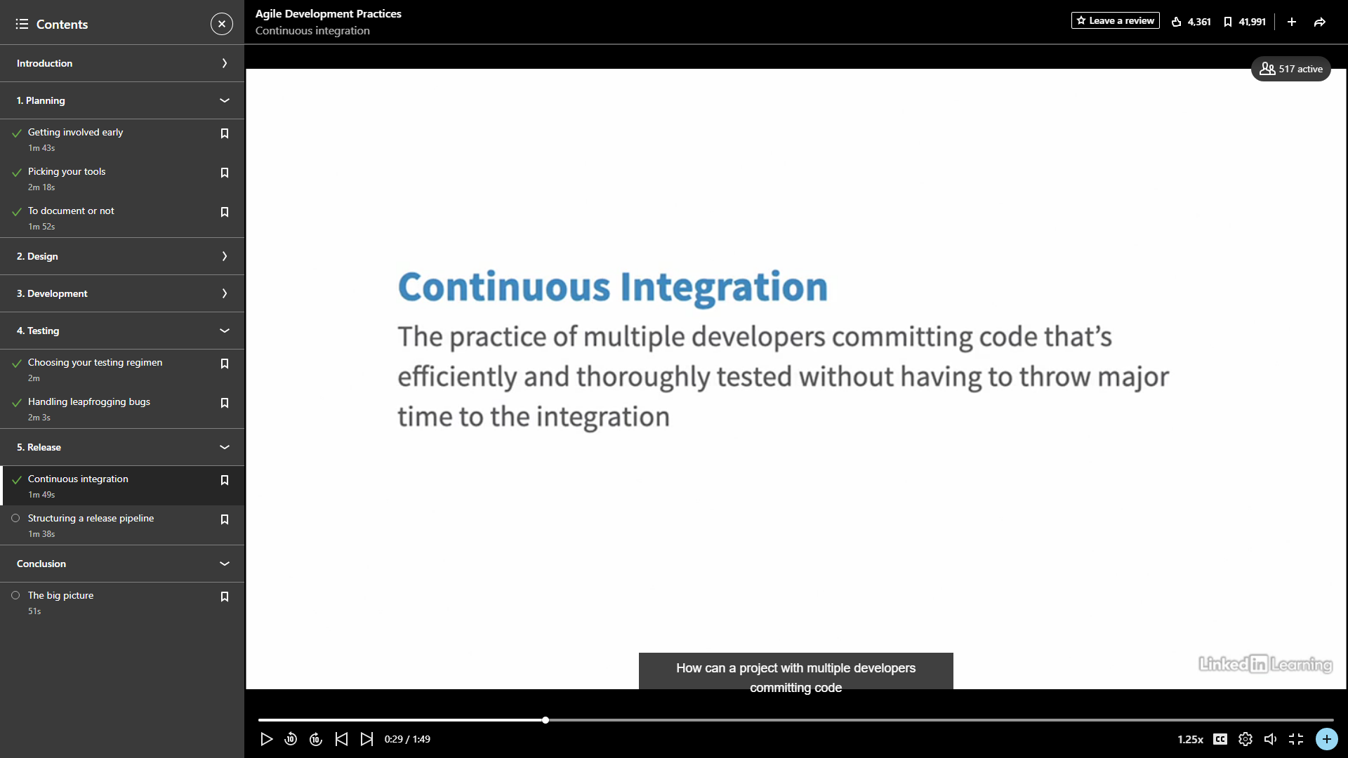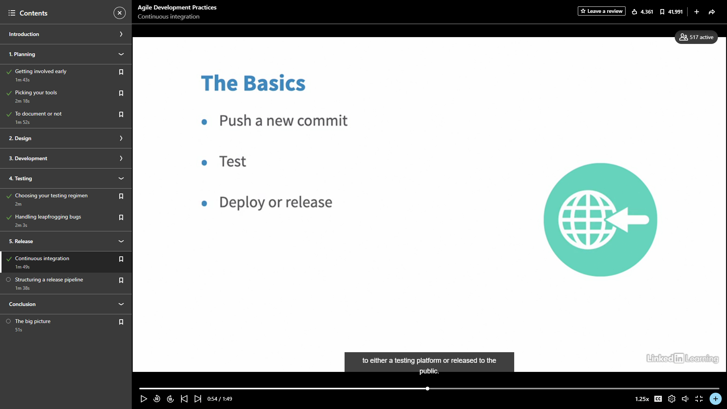

These the tools which makes easy to set up in CI

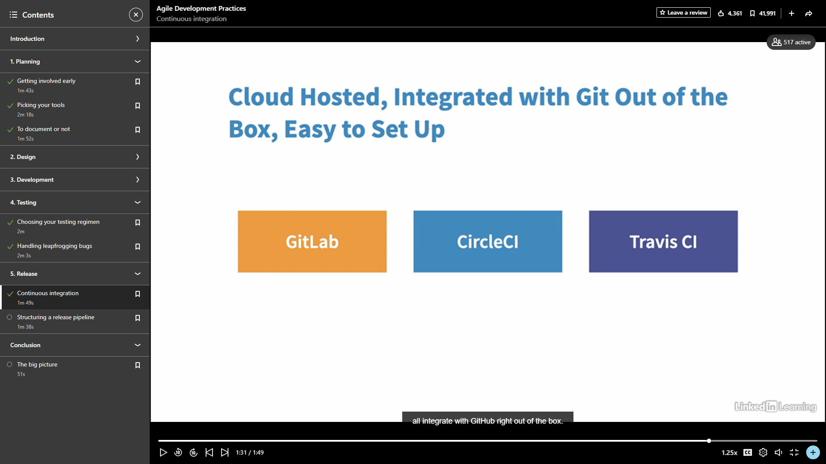

Release pipeline

A release pipeline is a conceptual process by which we take committed code into production. 